Case Study / Proposal:
Snow Plowing App

NMD442

Ezra Estey, Elliot Chandler (Wallace)
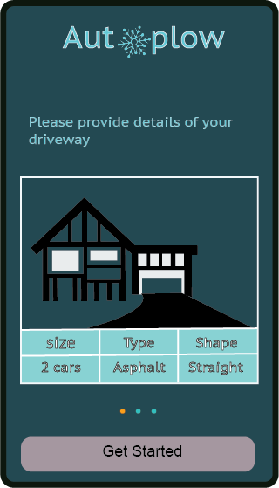

Table of Contents
Table of Contents 2
Abstract 3
Part 1: Project description / problem statement 3
Part 2: Hypothesis 3
Part 3: Budget 3
Part 4: Elevator pitch / value proposition 3
Part 5: Research 4
5.1: User interviews 4
5.2: Similar projects 4
5.3: Statistics 4
5.4: General knowledge of how plowing industry works 4
5.4.1: Timeliness 4
5.4.2: Efficiency 4
5.4.3: Meticulous 4
5.4.4: Communicative 5
5.5: Scenarios 5
5.5.1: Technical issues 5
5.5.2: Technology 5
5.5.3: Locations (of audience of app) 6
5.5.4: Demographics 6
Part 6: Use cases 6
Part 7: Personas 6
7.1: Customers 6
7.1.1: Customer 1 6
7.1.2: Customer 2 7
7.1.3: Customer 3 8
7.2: Plowing professionals 8
7.2.1: Driver 1 8
7.2.2: Driver 2 8
7.2.3: Driver 3 8
7.2.4: Driver 4 9
7.2.5: Driver 5 9
Part 8: Visuals 10
8.1: Mockups 10
8.2: Prototype 10
8.3: Use native visual language and styles 10
Part 9: Bibliography of sources 11

Abstract
This proposal outlines a project to create an on-demand or recurring-service-based client-server mobile app for coordinating snow plowing professionals with their clients.

Part 1: Project description / problem statement
This project aims to solve two problems, one problem for each type of user the app is designed to serve. The first problem the app aims to solve is to enable people to hire snow plowing professionals easily and efficiently, on-demand or based on configurable rules. Second, for snow plowing professionals, the app will enable them to connect to potential customers more easily, and to serve those customers better.

Part 2: Hypothesis
We predict that the development of this app will provide a dramatic increase in the ability of snow plowing professionals to connect and coordinate efficiently with clients.

Part 3: Budget
App development costs typically range from $25,000 to $1,000,000 or more, depending on the experience of the developers being hired, the technical complexity of the app, and other factors. [Savvy Apps] Because this is a fairly simple app from a technical perspective, it could probably be created by two to three people over a year or two, and cost somewhere from $50,000 to $100,000. If the app strategy should mimic the “Uber” private taxi app, then this app would also want to have facilities for the snow plowing company’s employees to monitor and manage the market to allow them to set rates depending on various factors. Having human analysis for this would increase the costs significantly, but could also allow for increased revenue through dynamic pricing. The costs of this would come from having to develop a system for realtime market management AI, from having to develop tools to facilitate humans managing this AI to ensure its accuracy, and from having to hire humans to monitor this. [Washington Post, Motherboard] (If such an AI were unmonitored, unfortunate results could occur. [CNN])

Part 4: Elevator pitch / value proposition
The goal is to create a snow plowing app that can accommodate anyone who cares to use it, whether it’s a freelancer, a company, or a group of friends, the user can be anybody. We want the app to also accommodate the customer, by adding additions to the app, allowing customers to keep track of the driver’s status (e.g. 10 minutes until arrival) and to provide reviews of each driver, so that the customer feels safe with the driver arriving at his or her home.

Part 5: Research

5.1: User interviews
We have interviewed multiple snow plowers and the snow plowers that are freelancers would prefer using the app if they didn’t have a route already, or if they had a large number of people that they work with. This is because the freelancers wouldn’t want to add on to the workload they already have. But with a large group of people, they could help those who use the app and those that use the site they already have.

5.2: Similar projects
There are other apps and services that have been similar to this proposal, including one for snow plowing. This app provides a service using an on-demand availability model similar to “Uber” private taxi app, and also allows scheduled service in a manner similar to traditionally scheduled plowing, but with greater ease of access and efficiency.

5.3: Statistics
The snow removal business accounts for approximately 350,000 jobs in US economy. [IBISWorld] Assuming this rate is common globally, this indicates a large potential audience for this app.

5.4: General knowledge of how plowing industry works
The four key traits a great snow plowing company has are good timeliness, efficiency, meticulous, and communicative.

5.4.1: Timeliness
The sense of urgency in the snow plowing business is very high. Snow plowing businesses have contracts with other companies and in order for that company to stay in business, the snow plows have to get the job done before that business opens. If not, the company will miss out on customers and money, and the snow plow company will most likely be out of a contract.

5.4.2: Efficiency
As a snowplowing business, you wouldn’t receive a lot of offers from other businesses if you only had small ATV’s as plows. The bigger the vehicle and plow, the quicker the job can be done, and the more hot a commodity you would be. When there’s a blizzard and the snow is coming down non-stop, a business would prefer a huge plow that can keep up with the snow and keep the driveways clear at all times. A small pickup truck wouldn’t be able to keep up. Most businesses prefer only hiring one or two snowplows. They would have to hire 10 snowplows if they were all attached to a small pickup truck, costing them more money.

5.4.3: Meticulous
Attention to detail is very important. When plowing people/businesses driveways, you need to make sure you’re placing the snow in an area that won’t make it’s way back in a business’s parking lot or person’s driveway. You also need to make sure you’re placing the snow in an area that won’t damage the property either.

5.4.4: Communicative
Keeping clients informed is of utmost importance. Clients need to know when you’re going to arrive and how long it took you to plow the driveway/parking lot so they can process the proper payment. There have been cases where snow plowing companies have forgotten about a person’s driveway/business and that person/business ended the contract they had with them right away. So out of all 4 traits, communication is the most important.

5.5: Scenarios

5.5.1: Technical issues
This app would use a client-server model, where a central server coordinates data synchronization between individual smartphone clients. One technical challenge that could hinder use and adoption of the app is the lack of availability of Internet access in many areas. While the area of Internet access is fairly large compared to historically when considering mobile access tools like Wi-Fi and Cellular, it is by no means complete, and even in wealthy areas with plenty of coverage, such as Mount Desert Island, Maine, USA, it has many areas of unavailability. Consequently, the app must work well when it is offline, handling a lack of connection gracefully. A good way to do this would be to have it gather data such as plowing requests when it is online, maintaining a database locally of this information in the phone, and synchronize changes with it with a central server whenever Internet access is available. This would allow the app to maintain full functionality, albeit not in real time, when it is offline, as frequently the case when traveling as a snow plowing professional would. This would also reduce the common problem of unavailable Internet access during snowstorms that is caused by infrastructure damage, by taking requests as it is used offline, and saving them up, and then sending them to the central server when it is possible to do so. Because the database of plow jobs would presumably be quite large, the set of data to be maintained locally should be filtered, to prevent the smartphone’s storage being consumed excessively by the app. To filter it, records could be omitted for fulfilled requests, as well as for any data points that are not nearby the location reported by the smartphone’s geolocation service.

5.5.2: Technology
The proposed tool is a smartphone app. This means it would typically be used with a touchscreen interface, and should be designed accordingly, taking into account the standard principles of mobile app development. Because it would need to run on various platforms (e.g. Android, iOS, Tizen) it is important to make sure it conforms to the standard user interface convention of whatever platform it runs on. The Qt toolkit provides a useful abstraction layer for writing apps that will conform appropriately to their environments, so it would be a good choice for the tool to use to develop the app. This would allow the app developers to focus on creating the functionality of the app without having to spend unneeded energy and effort on the already-solved problem of app portability. A potential pitfall would be developing it and testing using only a single platform, and then discovering that it did not work acceptably or violated platform conventions when used on other platforms, so using a platform abstraction layer like Qt would avoid that problem.

5.5.3: Locations (of audience of app)
People who use this app are in areas where there is enough snowfall to need plowing. Consequently, areas near the equator are not within the target audience for the app. This still leaves a large part of the world, though, where snowfall is a concern, and thus the app will be relevant. Consequently, the app development should take into account internationalization and localization concerns, and conduct user acceptance testing in a range of cultures to ensure that there are not oversights that would hinder its success.

5.5.4: Demographics
The audience of this app would include all adults living in the target locations as both snow plowing professionals and plow customers. It would also include high schoolers with jobs as snow plowing professionals, but not as plow customers as they are not homeowners. As this constitutes a diverse audience for the app, it is important to ensure accessibility for using it, such as usability by customers who use text-to-speech or Braille displays.

Part 6: Use cases
There are two primary categories of use case for the proposed app. First is the plowing professional, who would use the app as a means for connecting with potential customers. Second is the plowing customer, who would use the app to hire plow professionals to serve them.

Part 7: Personas

7.1: Customers

7.1.1: Customer 1
Jody is a 46-year-old on-call power company electrician, living in upstate New York, in a rural area near a town with 15,000 residents. They get about 45 inches of snow each winter, in six to ten storms in a typical year. Because Jody needs to go to job sites when there are power outages — typically during storms — they often have to leave their driveway when it is snowing. Because of this, having an on-demand plow service app is critical to their business, so they can get out of their driveway. Jody makes about $30,000 per year, and has a 13 year old Scion xB SUV as their vehicle. Because the vehicle isn't very good in the snow, and is unable to accommodate a plow, Jody can't plow their own driveway.
Jody has a smart phone, so they can use a Web interface for making snow plowing requests. Jody needs an app that is simple and easy to read, because they have a hard time using software that is low-contrast, small, or otherwise hard to see, due to failing eyesight.
For Jody, getting their driveway plowed quickly when they need to go to work is important. They are willing to pay more for plowing than the base rate, so they would find it useful to be able to offer a bounty for expedited service in the plow app. Jody has a few close friends, and goes to community events often, but is not influential in the community. Their personality is usually quiet but strong and not shy. Jody is not an early adopter of new technologies, usually waiting until they have become quite mainstream to investigate them. Jody values efficiency, precision, and focus in lifestyle.
Jody is a profitable regular customer of the snow plowing app. Jody is willing to use commercial branded products if the products serve their needs, and doesn't attempt to avoid them, but does not value brand loyalty or fashion over practicality. Jody’s perception of the plowing brand is as a simple, functional tool to enable them to get to work. They do not have any emotional attachment to the brand. Jody's perception of the value of the app is determined by how quickly they are able to get their driveway plowed at short notice when they need to go to work. Being told by their supervisor that they are needed to deal with damage to the municipal electrical infrastructure is their trigger to engage with the app.
Jody’s attitude toward the technology medium (smartphone app) is somewhat comfortable with installing apps, but without a lot of experience with a wide range of apps. Jody finds traditional desktop computer apps more comfortable, having extensive familiarity and expertise with Microsoft Office 2000, which they used in their previous job as a self-employed electrician for tracking customers.
Jody enjoys going to church suppers and other events in the community, and likes hiking in the mountains nearby. They are physically active and fit, and can easily shovel their driveway when they do not have to leave quickly. Because of this, Jody’s desire for efficiency means they do not want to hire a plow person to plow when they do not need to leave, since it would save money for them to shovel it themselves. Because it takes a while to shovel, being a large driveway, Jody needs to have plow service to be able to leave on demand for their work. They do not receive many visitors at their home, about two per month, and any visitors are scheduled in advance, so Jody does not need to keep the driveway plowed regularly in anticipation of unannounced visitors.

7.1.2: Customer 2
Gary is a new graduate from university, with a degree in mathematics. Gary is 24 years old, working as a data analyst for a cement processing company in North Dakota. Gary lives at the edge of a city with 40,000 residents. The city gets roughly four snow storms each winter, generally giving large amounts of snow, between 18 and 24 inches in a typical storm. Gary has a 9 to 5 job schedule, and needs to be able to leave and return from their driveway regularly. Gary’s interest in the plow service is to get a set-it-and-forget-it service for plowing, where they can specify that when there are more than three inches of snow, they want their driveway plowed. Gary makes about $45,000 per year, and their vehicle is a three year old Hyundai Santa Fe. The vehicle is quite good at driving in snow, but Gary does not want to have a plow on it, because a plow would add wear and tear and would require extra thought and focus, and their job needs a lot of energy, so Gary does not want to think about plowing themselves. However, because it is good in the snow, Gary does not want the driveway plowed at all when there are only three or fewer inches of snow, because they can just drive out on it.
Gary has a smartphone that they were given by a family member, but does not really use it much and is not comfortable using it. Gary is right-handed, but has right hand partially paralyzed from an accident while bicycling, so finds touch-driven interfaces difficult to use, and wants large tap targets in them. Gary is good at typing, using a left-hand Dvorak keyboard.
Gary is a loner, and does not really participate in the community, usually just staying home and watching sports on television after they get home from work. They are quite an energetic personality, but are too tired after work to do much. Gary is not interested in most computing technology, and avoids it when possible, but is skilled at doing statistical analysis using the R language in a command-line UNIX-like computing environment. Gary’s focus in life is to enjoy their work and learn more about mathematics.
Gary is an average customer of the snow plowing app, not being particularly profitable but not being unprofitable either. Gary avoids commercial branded products if possible, and only uses them when they are the most practical choice. They use smart phone and plowing app because of a family member who really wants Gary to get into this sort of thing. Gary is hostile to branding in general, but has no particular animosity towards the plowing app, as it has served them well. Gary’s perception of the value of the app is determined by how little they have to think about it: they are happiest when they can just configure regular plowing and set up the criteria for when they want to get plowing, and then leave it be and have their driveway plowed for them without having to put more thought into it.
Gary is not comfortable at all with smart phones, or electronics in general, outside of R and command-line UNIX.
Gary likes weightlifting on weekends, and is moderately fit. While they could shovel their driveway, for the same reason that they do not want to try to plow it themselves they do not want to: it would take away from their energy for work during the week.

7.1.3: Customer 3
Karan is a sixty-six year old retired pro tennis player. Karan is quite wealthy from having invested the tennis earnings very well, and got a degree in economics out of interest as a nontraditional student after retiring from tennis. Karan lives in Strasburg, in northern Virginia, with a population of about 7,000, and which gets a few storms each year with a small amount of snow. Karen’s interest in the plow service is to get a simple set-it-and-forget-it service for plowing, where they can request plowing for snow. Unlike Gary, Karan doesn’t want to think about the amount of snow, or anything like that. Karan’s vehicle is a one year old Tesla Model S. The vehicle is not very good at driving in snow. Karan has a top-of-the-line iPhone, and is an expert at using it, and has extensive experience as an IT power user in general. Karan is a very active person in the community, and is responsible for most community events.
Karan is an early tech adopter, and has a tendency toward brand loyalty.

7.2: Plowing professionals

7.2.1: Driver 1
Mike is a retired school teacher, 60, who has a good pension, but wants to make extra money on the side. He bought a plow and wants to make as many appointments as he can. If only there was an app for that!
Mike lives in upstate Vermont, where there are still a lot of houses in his neighborhood that still need plowing. Mike drives a 2015 GMC with great snow tires. He likes to use up to a full tank of gas for a full day’s work of plowing. He usually charges 10 to 20 dollars per driveway, depending on the size.

7.2.2: Driver 2
Eric lives in NYC, and during the winter, he makes a second income, plowing people’s driveways and taking tips. Eric is jealous of Uber and knows that with an app like that, he would not have to request money and instead the clients would be requesting him.

7.2.3: Driver 3
Adam lives in Bangor, ME. Himself and other people aid many people with disabilities, mental and physical. Unfortunately, many people don’t get to work or other activities on time because the plowing professionals take a route, like garbage workers, and get to certain houses later. With the app, people can make a request and the plowing professionals can arrive at people’s houses much quicker.
With a phone call, or request on the app, the closest plow person can arrive in a jiffy! The plow person needs to be quick and efficient. Instead of casually taking a route, the app will expose a lot more people who need their driveways plowed, specifically people with disabilities. Therefore, the more people that make requests, the more people that need to get plows and they must be time efficient.
The plow people can charge people a certain amount depending on the size of the driveway. Plus the plowers could charge for mileage.

7.2.4: Driver 4
Max is the most patient person ever and an early bird. Max gets lots of phone calls from the elderly, since he’s known around town, to plow their driveway. Unfortunately, a lot of elderly people cancel on Max because they’re paranoid and fear he’s going to be someone else and steal from them.
Max wishes there was an app so he doesn’t have as many people cancel on him. With the app, he could create a profile, giving a bio, picture, and ratings from other customers. That way, the elderly customers would know more about Max (Max doesn’t know everyone in town) and he wouldn’t have to worry as much of people cancelling on him.

7.2.5: Driver 5
Tony has 3 jobs, including plowing. Tony works for a plowing business and he is always sent to places hours away from him, because the town has no plowers. Tony wishes he could quit and be an independent freelancer, plowing people’s driveways where and when he wants and to make an amount he wants.
With the app, Tony can set a base price, and plow people’s driveways any time they want.
People would prefer requesting plow drivers via an app rather than calling and having to go through a list of options. Instead of the boss on the phone saying, “I’ll send my guy Mike”, the person can see if a guy like Mike is trustworthy and not someone who’s going to be an hour late.
Also, customers would prefer updates on where they are. You can’t check on the phone without waiting thirty minutes.

Part 8: Visuals

8.1: Mockups
Mockups, here also serving as as storyboards, are a visual presentation of the flow of a user’s interaction with the app.

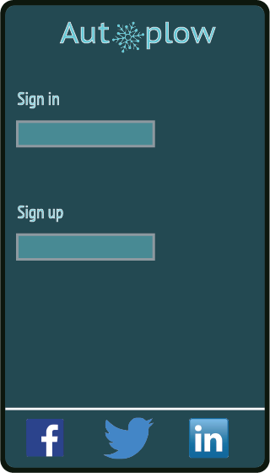 | 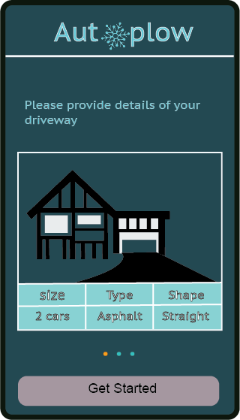 | 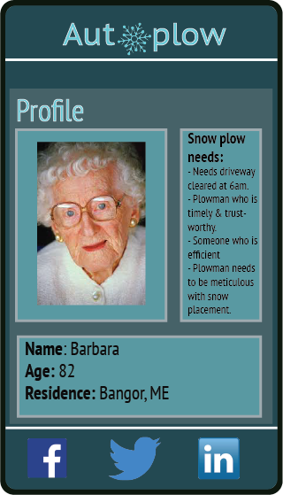
User logs in as an existing User or can sign up. | Example of a member’s request for a snow plowing professional | Profile page

8.2: Prototype
An interactive prototype for this app would be a good deliverable target for the next stage of app development. This would allow hands-on testing of the app’s behavior and basic user interface without needing to invest in the full expense of developing it with a given user interface until it had been tested.

8.3: Use native visual language and styles
The various smartphone platforms each have their own conventions and standards for how apps should work visually, and how user interface elements should look and behave. By using a platform abstraction toolkit like Qt, these issues will be handled automatically, and it will not be necessary to develop a visual language or style guide specifically for this app. This has the added benefit of making the app already familiar to users, and thereby being easier to use because it conforms to their existing expectations about how apps will work. While some apps use custom-developed user interface controls, style, and/or behavior, this is generally a hindrance to effective user experience for these apps as it violates the users’ expected norms regarding apps’ behavior in that platform. [Baymard]

Part 9: Bibliography of sources
- [IBISWorld] https://www.ibisworld.com/industry-trends/specialized-market-research-reports/specialist-engineering-infrastructure-contractors/general/snowplowing-services.html
- https://nsidc.org/cryosphere/snow/removal.html
- https://www.accuweather.com/en/weather-news/snow-removal-industry-shifts-to-uber-like-on-demand-plow-services/54737983
- http://success.hindsitesoftware.com/field-service-software-blog/bid/286801/4-Traits-of-a-Great-Snow-Removal-Business
- [Savvy Apps] https://savvyapps.com/blog/how-much-does-app-cost-massive-review-pricing-budget-considerations
- [Baymard] https://baymard.com/blog/custom-vs-native-ui
- [Washington Post] https://www.washingtonpost.com/news/wonk/wp/2015/04/17/how-uber-surge-pricing-really-works/
- [Motherboard] https://motherboard.vice.com/en_us/article/mgbz5a/ubers-phantom-cabs
- [CNN] http://money.cnn.com/2017/06/04/technology/uber-london-attack-surge-pricing/index.html

